Section A study guide

Quick Check
For each experiment check that you can do can do each of the following:
- Draw a fully labelled diagram which includes all essential apparatus (have you included the apparatus necessary to obtain values for both variables?)
- Be able to state how the two sets of values were obtained (this is a very common question)
- Describe what needs to be adjusted to give a new set of data
- Write down the relevant equation if there is one associated with the experiment
- Be able to state how the data in the table will need to be adjusted.
- Be able to list three sources of error/precautions

If the experiment involves a graph
- Know how the data provided will need to be adjusted
- Know what goes on each axis
- Know how to use the slope of the graph to obtain the desired answer

Note that all documents can be found in the revision page of www.thephysicsteacher.ie

Contents
SECTION A EXAM TECHNIQUE 2
DRAWING THE GRAPH 3
WHAT GOES ON WHAT AXIS? 4
SUMMARY OF THE GRAPHS 4
EXPERIMENT QUESTIONS (SECTION A) BY YEAR 6
SECTION A COMMON THEORY QUESTIONS 7

SECTION A EXAM TECHNIQUE
You must know all mandatory experiments inside out

You will be given a set of results and will be asked to do some of the following:
- Draw a labelled diagram.
- Explain how the values were obtained.
- To calculate some quantity (e.g. Specific Heat Capacity) or to verify a Law (e.g. Conservation of Momentum, Snell’s Law etc).
- Some shorter questions on sources of error, precautions etc in relation to the performance of the experiment.
- At least one of the questions will require a graph to be drawn. In such cases the slope of the graph will usually have to be calculated. The significance of the slope of the graph is determined by comparing it to a relevant formula (which links the two variables on the graph).

Note
The data given will frequently have to be modified in some way (e.g. you may need to square one set of values or find the reciprocal etc) before the graph is drawn. This modification is determined by comparing it to the relevant formula which links the two variables.

When revising Section A make sure that you can do each of the following for every experiment:
- Draw a labelled diagram of the experimental set-up, including all essential apparatus.
The first step in the procedures should then read “we set up the apparatus as shown in the diagram”.
- Describe how to obtain values for both sets of variables
- Describe what needs to be adjusted to give a new set of data
- Say what goes on the graph, and which variable goes on which axis
- Know how to use the slope of the graph to obtain the desired answer (see below).
- List two or three precautions; if you are asked for two precautions, give three - if one is incorrect it will simply be ignored.
- List two or three sources of error.

Misc Points
- The graph question is usually well worth doing.
- Learn the following line off by heart as the most common source of error: “parallax error associated with using a metre stick to measure length / using a voltmeter to measure volts etc”.
- Make sure you understand the concept of percentage error; it’s the reason we try to ensure that what we’re measuring is as large as possible.
- There is a subtle difference between a precaution and a source of error – know the distinction.
- When asked for a precaution, do not suggest something which would result in giving no result, e.g. “Make sure the power-supply is turned on” (a precaution is something which could throw out the results rather than something which negates the whole experiment).
- To verify Joule's Law does not involve a Joulemeter
- To verify the Conservation of Momentum – the second trolley must be at rest.
- To verify the laws of equilibrium - the phrase ‘spring balance’ is not acceptable for ‘newton-metre’.
- To measure the Focal length of a Concave Mirror or a Convex Lens:
Note that when given the data for various values of u and v, you must calculate a value for f in each case, and only then find an average. (As opposed to averaging the u’s and the v’s and then just using the formula once to calculate f). Apparently the relevant phrase is “an average of an average is not an average”.

DRAWING THE GRAPH

- You must use graph paper and fill at least THREE QUARTERS OF THE PAGE.
- Use a scale which is easy to work with i.e. the major grid lines should correspond to natural divisions of the overall range.
- LABEL THE AXES with the quantity being plotted, including their units.
- Use a sharp pencil and mark each point with a dot, surrounded by a small circle (to indicate that the point is a data point as opposed to a smudge on the page.
- Generally all the points will not be in perfect line – this is okay and does not mean that you should cheat by putting them all on the line. Examiners will be looking to see if you can draw a best-fit line – you can usually make life easier for yourself by putting one end at the origin. The idea of the best-fit line is to imagine that there is a perfect relationship between the variables which should theoretically give a perfect straight line. Your job is to guess where this line would be based on the available points you have plotted.
- Buy a TRANSPARENT RULER to enable you to see the points underneath the ruler when drawing the best-fit line. Make that a LONG transparent ruler. See next point.
- BE VERY CAREFUL drawing a line if your ruler is too short to allow it all to be drawn at once.
Nothing shouts INCOMPETENCE more than two lines which don’t quite match.

- DO NOT JOIN THE DOTS if a straight line graph is what is expected. Make sure that you know in advance which graphs will be curves.
- Note that examiners are obliged to check that each pint is correctly plotted, and you will lose marks if more than or two points are even slightly off.
- When calculating the slope choose two points that are far apart; usually the origin is a handy point to pick (but only if the line goes through it).
- When calculating the slope DO NOT TAKE DATA POINTS FROM THE TABLE of data supplied (no matter how tempting!) UNLESS the point also happens to be on the line.
If you do this you will lose beaucoup des marks and can kiss goodbye any chance of an A grade.
Do you understand why you cannot do this?

WHAT GOES ON WHAT AXIS?
Option one
To show one variable is proportional to another, the convention is to put the independent variable on the x–axis, and the dependant variable on the y-axis, (from y = fn (x), meaning y is a function of x). The independent variable is the one which you control.

Option two
If the slope of the graph needs to be calculated then we use a difference approach, one which often contradicts option one, but which nevertheless must take precedence. In this case we compare a formula (the one which connects the two variables in question) to the basic equation for a line: y = mx.

See if you can work out what goes on what axis for each of the following examples and in each case establish the significance of the slope of the graph (they get progressively trickier):
- To Show Force is proportional to Acceleration
- Ohm’s Law
- Snell’s Law
- Acceleration due to gravity by the method of free-fall
- Acceleration due to gravity using a Pendulum
- Frequency proportional to length
- Frequency proportional to tension

There is usually a follow-up question like the following;
“Draw a suitable graph on graph paper and explain how this verifies Snell’s Law”.
There is a standard response to this;
“The graph of Sin i against Sin r resulted in a straight line through the origin (allowing for experimental error), showing Sin i is directly proportional to Sin r, and therefore verifying Snell’s Law”.

If you are asked any questions to do with the information in the table, you are probably being asked to first find the slope of the graph, and use this to find the relevant information.

And always, always, label your axes.

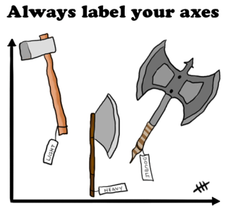

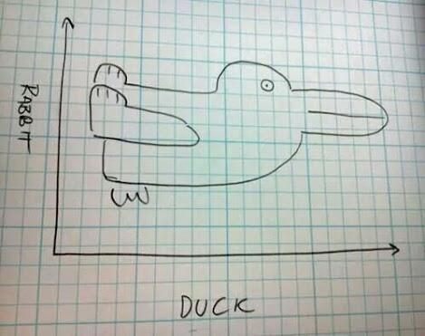
SUMMARY OF THE GRAPHS

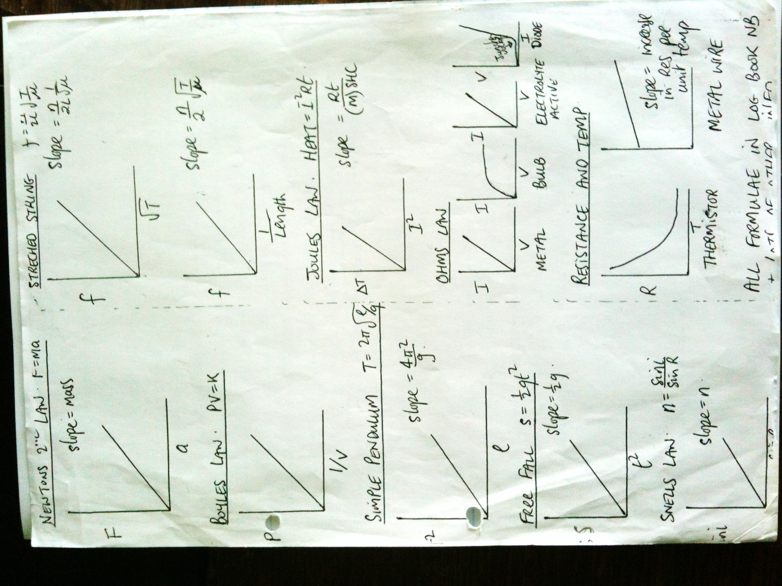

EXPERIMENT QUESTIONS (SECTION A) BY YEAR

Experiment Title | 14 | 13 | 12 | 11 | 10 | 09 | 08 | 07 | 06 | 05 | 04 | 03 | 02
Concave Mirror |  | 3 |  |  |  |  |  | 3
Convex Lens |  |  | 2 |  |  | 2 |  |  |  |  |  | 3
Refractive Index | 2 |  |  |  | 3 |  |  |  |  | 3
Verify F = Ma |  |  |  |  | 1
g by free-fall |  |  |  |  |  | 1 |  |  |  |  | 1
Conservation of Momentum | 1 |  |  | 1 |  |  |  |  |  | 1
Measurement of g using Simple Pendulum |  |  | 1 |  |  |  | 1 |  | 1
Calibration Curve

Specific Heat Capacity |  |  |  |  |  |  |  | 2
Latent Heat of Vapourisation |  |  |  |  | 2 |  |  |  |  | 2 |  | 2
Latent Heat of Fusion |  |  |  |  |  |  | 2 |  |  |  |  |  | 2
Boyle’s Law |  | 2 |  | 2 |  |  |  |  |  |  |  | 1
Laws of Equilibrium |  | 1 |  |  |  |  |  | 1 |  |  |  |  | 1
Speed of Sound | 3 |  |  |  |  |  |  |  | 3
Natural Frequency and Length |  |  | 3 |  |  |  |  |  |  |  | 3
Natural Frequency and Tension |  |  |  |  |  | 3 |  |  |  |  | 3 |  | 3
Wavelength of Light |  |  |  | 3 |  |  | 3 |  | 2 |  | 2
Joule’s Law | 4 |  |  |  |  |  |  |  | 4 |  |  | 4
Ohm’s Law |  | 4
V I for a Filament Bulb |  |  |  |  |  |  |  |  |  | 4
V I for copper sulphate |  |  |  | 4 |  |  |  |  |  |  |  |  | 4
Semiconductor Diode |  |  | 4 |  |  |  |  | 4
R versus Temp for a Metal |  |  |  |  |  |  | 4
R versus Temp for Thermistor |  |  |  |  | 4
Resistivity |  |  |  |  |  | 4 |  |  |  |  | 4

SECTION A COMMON THEORY QUESTIONS

Most of the questions in Section A are repetitive; the following represent some of the most common questions asked.

The standard questions will usually be followed by one or two tricky questions which are looking to test for a deeper understanding of what’s going on.

I have highlighted the most common of these below.
Note that some questions are common to many experiments and so the answers should be learned off like a mantra. Some examples:

Why is it important to keep (variable X) constant throughout the experiment?
Answer:
You can only investigate the relationship between two variables at any one time and variable X would be a third variable.

Why should room temperature be approximately half-way between initial and final temperature (for Heat experiments)?
Answer:
So that the heat lost to the environment when the system is above room temperature will cancel out the heat taken in from the environment when the system is below room temperature.

What is the advantage in keeping the length/time/mass as large as possible?
Answer:
A larger length/time/mass would result in a smaller percentage error.

Be careful / specific when referring to parallax error
“To avoid the error of parallax when measuring the length with a metre stick” is acceptable.
“To avoid parallax error” is not.

All of the following are taken from past papers.
Make sure when answering these that you check your answer against the appropriate marking scheme; knowing the answer in your head and writing it down in such a way that you get full marks in an exam are two very, very different things.
Measurement of the focal length of a concave mirror
- How was an approximate value for the focal length found?
- What was the advantage of finding the approximate value for the focal length?

Verification of Snell’s law of refraction / to measure the refractive index of a glass block
- Why would smaller values lead to a less accurate result?

Measurement of the focal length of a convex lens
- Why is it difficult to measure the image distance accurately?
- Give two precautions that should be taken when measuring the image distance.
- What difficulty would arise if the student placed the object 10 cm from the lens?

Measurement of acceleration due to gravity (g) using the freefall method
- Indicate the distance s on your diagram.
- Describe how the time interval t was measured.
- Give two ways of minimising the effect of air resistance in the experiment.

To show that acceleration is proportional to the force which caused it
- How was the effect of friction reduced in the experiment?
- Using your graph, find the mass of the body.
- On a trial run of this experiment, a student found that the graph did not go through the origin.
Suggest a reason for this.
- Describe how the apparatus should be adjusted, so that the graph would go through the origin.

To verify the principle of conservation of momentum
- How could the accuracy of the experiment be improved?
- How did the student know that body A was moving at constant velocity?
- How were the effects of friction and gravity minimised in the experiment?

Verification of Boyle’s law
- Why should there be a delay between adjusting the pressure of the gas and recording its value?
- Describe how the student ensured that the temperature of the gas was kept constant.

Investigation of the laws of equilibrium for a set of co-planar forces
- Describe how the centre of gravity of the metre stick was found.
- How did the student know that the metre stick was in equilibrium?
- Why was it important to have the spring balances hanging vertically?

Investigation of the relationship between periodic time and length for a simple pendulum and hence calculation of g
- Give two factors that affect the accuracy of the measurement of the periodic time.
- Why did the student measure the time for 30 oscillations instead of measuring the time for one?
- How did the student ensure that the length of the pendulum remained constant when the pendulum was swinging?
- Explain why a small heavy bob was used.
- Explain why the string was inextensible.
- Describe how the pendulum was set up so that it swung freely about a fixed point.

Measurement of the specific heat capacity of water
- Explain why adding a larger mass of copper would improve the accuracy of the experiment.

Measurement of the specific latent heat of fusion of ice
- Why was melting ice used?
- Why was dried ice used?
- Explain why warm water was used.
- What should be the approximate room temperature to minimise experimental error?
- What was the advantage of having the room temperature approximately halfway between the initial temperature of the water and the final temperature of the water?

Measurement of the specific latent heat of vaporisation of water
- How was the water cooled below room temperature?
- How was the steam dried?
- Why was dry steam used?
- Why was a sensitive thermometer used?
- A thermometer with a low heat capacity was used to ensure accuracy. Explain why.

To measure the speed of sound in air
- How was it known that the air column was vibrating at its first harmonic?

Investigation of the variation of fundamental frequency of a stretched string with length
- How did the student know that the string was vibrating at its fundamental frequency?

Investigation of the variation of fundamental frequency of a stretched string with tension
- Why was it necessary to keep the length constant?
- How did the student know that the string was vibrating at its fundamental frequency?
- How did the student know that resonance occurred?
- Use your graph to calculate the mass per unit length of the string.

Measurement of the wavelength of monochromatic light
- What effect would each of the following changes have on the bright images formed:
- using a monochromatic light source of longer wavelength
- using a diffraction grating having 200 lines per mm
- using a source of white light instead of monochromatic light?
- Calculate the maximum number of images that are formed on the screen.
- The laser is replaced with a source of white light and a series of spectra are formed on the screen.
Explain how the diffraction grating produces a spectrum.
- Explain why a spectrum is not formed at the central (zero order) image.
- The values for the angles on the left of the central image are smaller than the corresponding ones on the right. Suggest a possible reason for this.

To measure the resistivity of the material of a wire
- Why did the student measure the diameter of the wire at different places?
- The experiment was repeated on a warmer day. What effect did this have on the measurements?
- Give two precautions that should be taken when measuring the length of the wire.

To investigate the variation of the resistance of a thermistor with temperature
- Use your graph to estimate the average variation of resistance per Kelvin in the range 45 °C – 55 °C.
- In this investigation, why is the thermistor usually immersed in oil rather than in water?

To investigate the variation of current with potential difference for copper electrodes in a copper-sulphate solution
- What was observed at the electrodes as current flowed through the electrolyte?
- Draw a sketch of the graph that would be obtained if inactive electrodes were used in this experiment.

To investigate the variation of current with potential difference for a semiconductor diode
- What is the function of the 330 Ω resistor in this circuit?
- The student continued the experiment with the connections to the semiconductor diode reversed.
What adjustments should be made to the circuit to obtain valid readings?
- Draw a sketch of the graph obtained for the diode in reverse bias.

To verify joule’s law
- Why was a fixed mass of water used throughout the experiment?
- Given that the mass of water in the calorimeter was 90 g in each case, and assuming that all of the electrical energy supplied was absorbed by the water, use the graph to determine the resistance of the heating coil.
The specific heat capacity of water is 4200 J kg^{–1} K^{–1}.
- Explain why the current was allowed to flow for a fixed length of time in each case.

